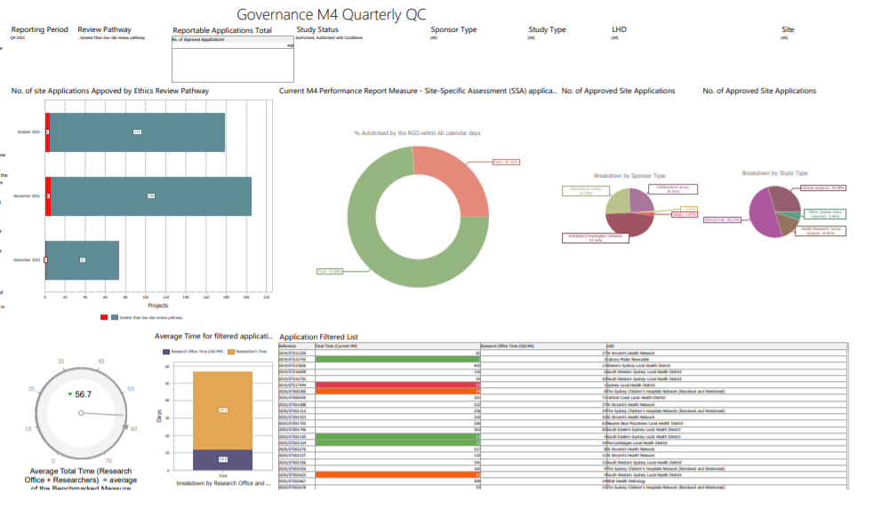
Instructions for RGOs:
The first row of this dashboard has 7 filters, and 1 reporting field showing the reportable number of applications after applying the filters.
The following are the filters settings to view your live Metric 4 performance data:
‘Reporting Period’ = this quarter, or any quarter whose data you plan to check
‘Review Pathway’ = Greater than low risk+ [blank field]
‘Study Status’ = Authorised/ Authorised with Condition
The other filters should remain unchanged unless used for data cleaning purposes.

The second row presents 4 graphs for studies authorised within the ‘Reporting Period’. From left to right, they are respectively showing:
- No. of site applications approved broken down by ‘Review Pathway’.
  - You should only see the teal coloured bars representing ‘Greater than low risk’ studies shown here if your data is clean.
  - If you are seeing red coloured bars in this graph, and a [blank field] was linked with the red colour in the legend of the graph, you need to fill in the blank field by assigning the study with a review pathway before the data extraction date.
  - To achieve this purpose, click on the red bars representing [blank field], the study will show up in the ‘Application Filtered List’ table in the third row of the dashboard.
  - Click on the ‘Reference’ for the study in the ‘Application Filtered List’ to access each application and make changes as appropriate.
- M4 – Percentage of Site-Specific Assessment (SSA) authorised within the 60-day benchmark (this is the Metrics 4 measure in the CE’s performance report).
- A breakdown of the No. of approved applications by Sponsor type.
  - You should only see the brown ‘Commercial entity’, green ‘Collaborative group’, and blue ‘Institution/Investigator-initiated’ if your data is clean.
  - If you are seeing red coloured pie that is ‘other’ or yellow coloured pie that is [blank field] in this graph, you need to fill in the blank field and correct the ‘other’ sponsor type by assigning the study with one of the three sponsor type, before the data extraction date.
  - To achieve this purpose, go the filter for ‘sponsor type’ in the first row of the dashboard and tick only ‘other’ and [blank field], and the corresponding study will show up in the ‘Application Filtered List’ table in the third row of the dashboard.
  - Click on the ‘Reference’ for the study in the ‘Application Filtered List’ to access each application and make changes as appropriate.

- A breakdown of the No. of approved applications by Study type.
  - You should only see the olive coloured ‘Clinical research’, dark mustard coloured ‘Clinical trial’, the green ‘Health research’ and purple ‘Other (please state, required)’ if your data is clean.
  - If you are seeing the red coloured pie that is a [blank field], you need to fill in the blank field by assigning the study with one of the four study types, before the data extraction date.
  - To achieve this purpose, go to the filter for ‘study type’ in the first row of the dashboard and tick only the [blank field], and the corresponding study will show up in the ‘Application Filtered List’ table in the third row of the dashboard.
  - Click on the ‘Reference’ for the study in the ‘Application Filtered List’ to access each application and make changes as appropriate.

The third row of the Dashboard contains two graphs on the average time:
- The gauge shows the average total time for the filtered applications.
  - Please note the ‘total time’ is not the performance indicator. It is the measure used to compare to the ’60 day benchmark’ to determine the % applications approved within the 60 benchmark. The % applications within the benchmark is the actual Metric 4 performance indicator.
- The stacked bar graph shows the breakdown of the total time by research office time and researcher time.
- The Application Filtered list shows a list of applications fitting the filtering criteria.

